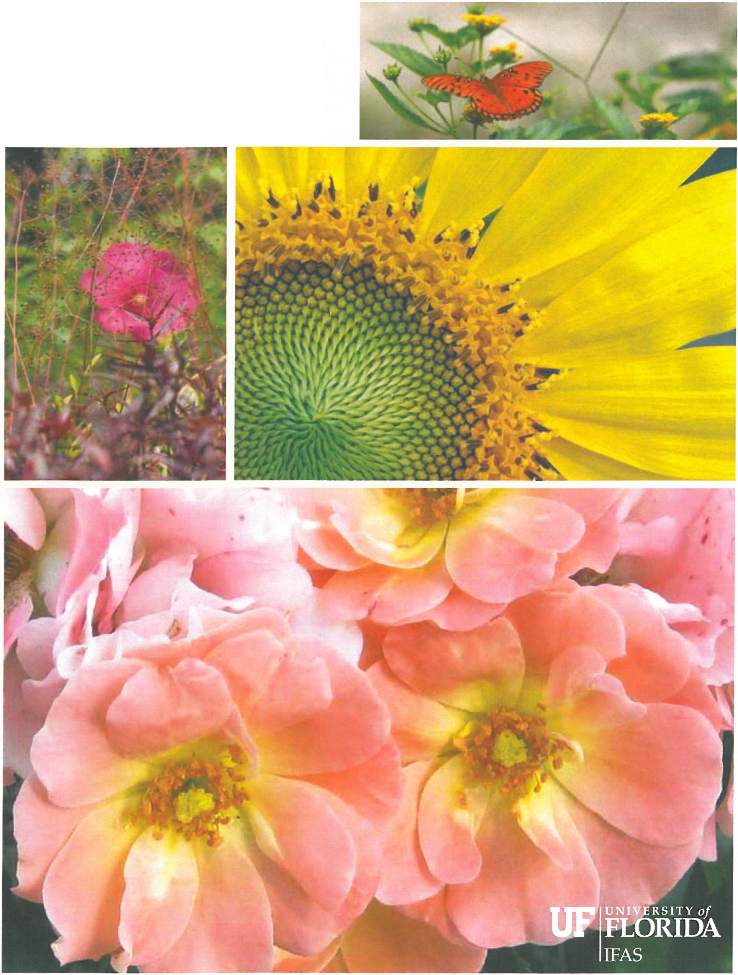
Gardens of the

BIG BEND

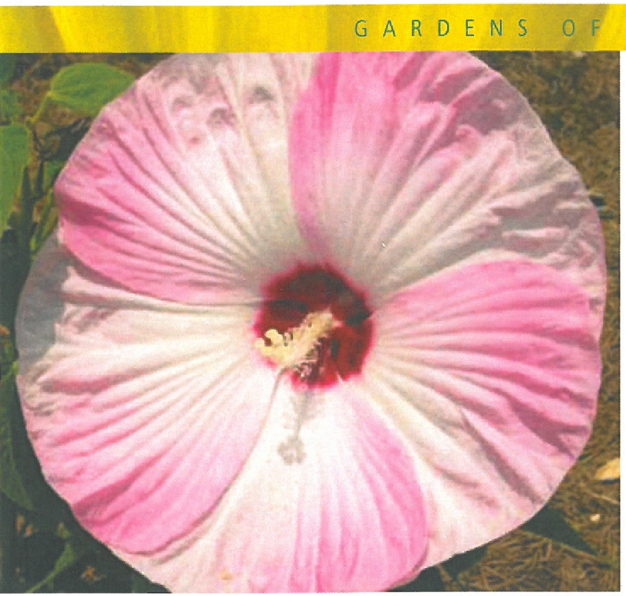

Introduction
Gardening is one of America's most popular activities. Landscaping adds value as well as beauty when properly planned and maintained.
Ideally, landscapes should enhance the environment without negative impact, but too often gardeners inadvertently select inappropriate plants for their landscapes. Plants may be mismatched due to lack of adaptability to soil and environmental conditions or inappropriate plant growth, size or other characteristics for the plant's intended use.
Mismatched plants often receive excessive amounts of pesticides, water, fertilizer, labor and other inputs as gardeners struggle to maintain plant health and appearance. Also, despite their best efforts, gardeners'
attempts to correct plant problems often lead to waste, pollution and health hazards.
Public gardens may serve as a venue to teach and enlighten frustrated gardeners and misinformed homeowners. Public gardens can display regionally adapted plants and showcase proper plant care while providing an inspiring setting to learn about gardening methods.
We envision Gardens of the Big Bend to be a place of beauty, a place to be close to nature, a place to relax and experience the joys of flowers, shrubs, trees and other plants; a center of learning where youth, gardeners, nursery growers, landscape professionals and other visitors can learn about plants and gardening methods that beautify our lives while enhancing the environment.
T H E B I G B E N D

Proposal
Gardens of the Big Bend will help gardeners, nursery growers and landscapers by researching and demonstrating plants and landscaping methods best adapted to the greater north Florida region. As a living laboratory, Gardens of
the Big Bend will evaluate new plants to determine their growth characteristics and adaptability to north Florida's climate.
As a living classroom, Gardens of the Big Bend will display plants best-suited to the area and demonstrate environmentally friendly landscape styles to students of all ages, ranging from homeowners and youth groups to garden club members, Master Gardeners, nursery growers and landscapers. As a garden planted with trees, shrubs
and flowers, Gardens of the Big Bend will create a beautiful oasis for community residents as well as a picturesque learning environment for visitors.
All of this will take place in a beautiful setting of trees and garden beds linked by pathways. Trails and a directory will lead to planned and existing research gardens showcasing crape myrtle, magnolia, hydrangea and many other plants under study at the North Florida Research and Education Center at Quincy. Over time, these pre-existing plantings may be integrated with the Gardens to effectively enlarge them.

Mission
Our goal is that the Gardens of the Big Bend become a regional showcase displaying the best plants and gardening methods as well as to:
- Serve as a living laboratory to evaluate new plants for gardeners, nursery growers and landscapers
- Promote garden plants adapted to regional landscapes
- Demonstrate environmentally sound principles of landscaping
- Provide a beautiful and educational environment for students, visitors and local/regional citizens

Design
The Gardens of the Big Bend are envisioned as a series of landscapes, each emphasizing an important garden principle, aesthetic, environmental condition or plant

GARDENS 0F

group. The first area to be developed is the Discovery Garden, emphasizing new, improved and underutilized plants. Initial plantings occurred in winter, 2009.
Examples of other proposed theme gardens include:
- Beauty in the Shadows (hydrangea, azalea and other plants for shaded areas)
- The Palms (emphasizing hardy palms and other palm-like plants)
- Aboriginal Garden (native plants)
- Garden of Tears (emphasizing weeping plants)

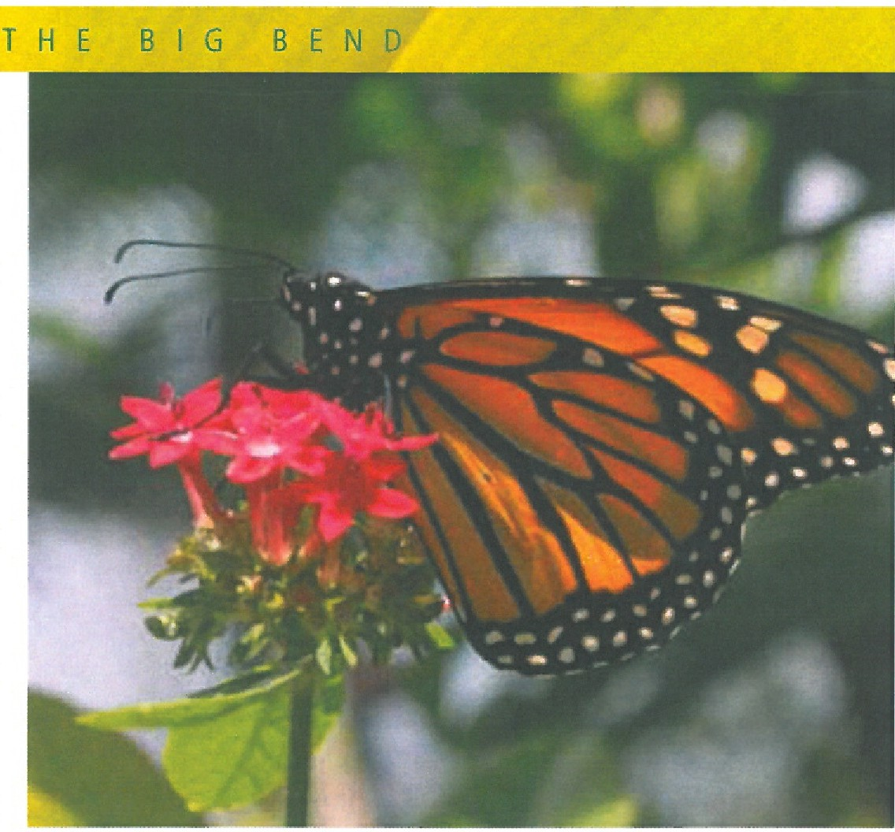
- Jurassic Park Children's Garden (a fun and educational garden for children emphasizing plants from the age of dinosaurs)
- Garden of Drought Defying Plants (cacti, succulents, bromeliads, bulbs and other plants that tolerate drought)
- Celebrating Camellias and Southern Heritage Plants (a garden focusing on camellias and including other plants important to traditional Southern gardeners)
- Eating Your Way to Gardening (edible landscaping)
- Preserving Florida's Wildlife and Natural Resources with Wetlands
Other garden types that may be considered include bulbs, vines, conifers, ornamental grasses, gardening in the sun, water gardens, container gardening, and gardening for butterflies, bees, songbirds and other wildlife.
In addition, we anticipate a learning center, an open-air classroom as the perfect venue for teaching students of all ages.

Planning and Development
Planning, installation and maintenance of the Gardens of the Big Bend are major efforts of the nonprofit organization, Gardening Friends of the Big Bend, Inc.
(GFBB). Members of GFBB actively volunteer at NFREC to develop and maintain demonstration gardens as well as assist faculty with research. Creative fundraising by GFBB supplements the NF REC budget. Given the scope of the Gardens, endowments and gifts are sought to assist with

development of individual garden beds as well as the overall garden.

Matching Gift Programs
While donations of any size are welcome, the State of Florida currently provides generous matching funds for endowed gifts of $100,000 or more through its Major Gifts Trust Fund. Private gifts may be matched according to the following levels:
- $100,000 to $599,999 gifts matched 50%
- $600,000 to $1,000,000 gifts matched 70%
- $1,000,001 to $1,500,000 gifts matched 75%
- $1,500,001 to $2,000,000 gifts matched 80%
- $2,000,001 of more gifts matched 100%

About Gardening Friends of the Big Bend, Inc.
GFBB is a group of avid gardeners and professional horticulturists who support and assist the faculty and staff of NFREC to accomplish their ongoing mission. Dr.
Gary Knox is the faculty liaison who coordinates activities between the GFBB and NFREC.
Goals of Gardening Friends of the Big Bend, Inc. include:
- Expanding outreach by fostering research and providing educational programs through partnerships with NFREC, other community organizations, schools and the horticultural industry;

GARDENS 0F THE BIG BEND

- Organizing and participating in special events in support of NFREC; performing routine garden maintenance and operation; and developing new and expanded public gardens; and
- Generating additional resources to enhance the mission and goals adopted by GFBB, including soliciting donations and grants, planning fund raising activities, and volunteering time, materials and equipment.

About The North Florida Research and Education Center
The University of Florida/lFAS North Florida Research and Education Center at Quincy is a 900+ acre facility with staffing and laboratory facilities involved in all aspects of agricultural research, including ornamental plants and gardening.
Current gardens and plant collections include:
- Gardens of the Big Bend, a regional showcase for plants and gardening with individual theme gardens
- Magnolia and Hydrangea Garden, with more than 100 different magnolias and 30+ cultivars of hydrangea
- Crape myrtle Research Planting, with more than 60 types
- Ornamental Vine Collection
- Conifer Garden
- Shrub Rose Research Planting, featuring new and antique shrub roses; and
- Perennial Trial Garden, featuring hardy hibiscus and salvias

In Conclusion
With your support, the Gardens of the Big Bend will be a place of beauty, a place to relax and experience the joys of flowers, shrubs, trees and other plants. Our vision is to inspire visitors to create and beautify their own gardens
based on the knowledge they gain from their experiences at the Gardens of the Big Bend.
We look forward to building a strong and beneficial partnership with you through your interest and support of the Gardens of the Big Bend at the North Florida Research and Education Center at Quincy. Thank you for your consideration.
A real garden where one can enter in and forget the whole world cannot be made in a day, a month or a lifetime. It must be planned for, and waited for, and loved into being.
-Ancient Chinese Proverb

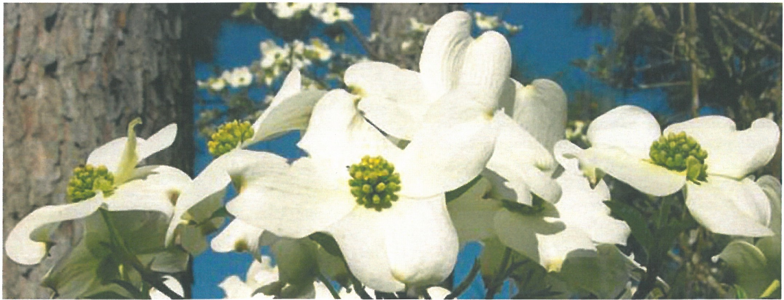

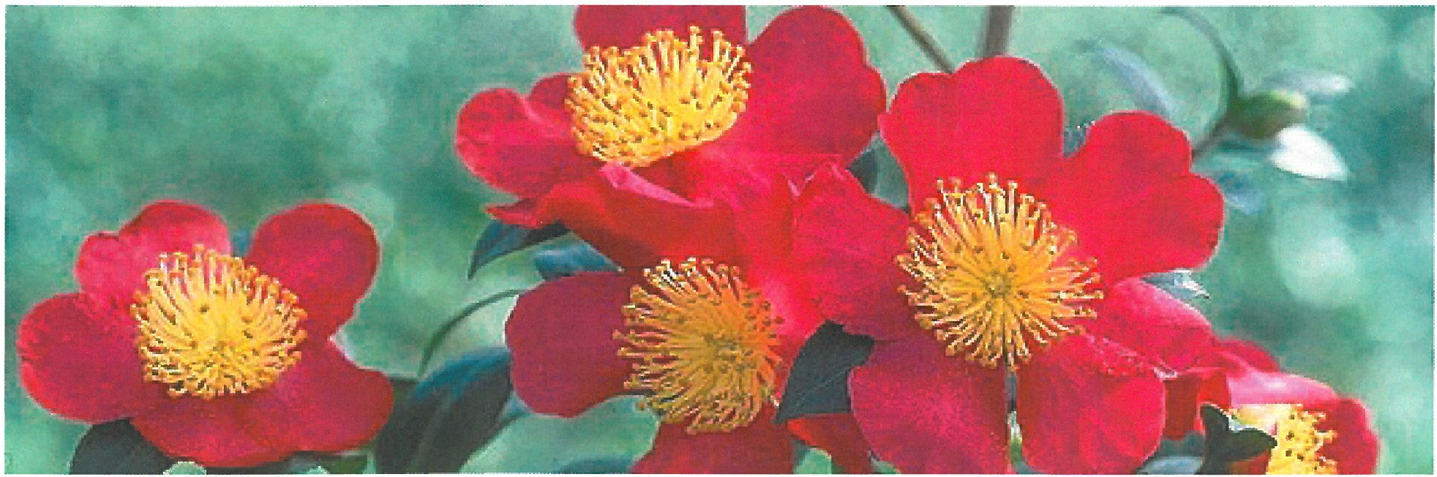

Gardens of the Big Bend
Construction Cost and Naming Endowment Menu

Name of Bed | Size of Bed (square feet) | Cost of Construction | Endowment  Amount to Name Garden
Discovery Garden  (Discovering new, improved and under-utilized plants for southern gardens) | 20,195 | $70,000 | $280,000
Beauty in the Shadows  (Hydrangea, Azalea and other plants for Shaded Areas) | 10,317 | $45,000 | $160,000
The Palms  (Emphasizing hardy palms and other palm-like plants) | 10,196 | $45,000 | $130,000
Aboriginal Garden  (Native plants) | 5,810 | $30,000 | $150,000
Garden of Tears  (Emphasizing weeping plants) | 5,753 | $30,000 | $150,000
Jurassic Park  (Emphasizing plants from the age of dinosaurs) | 5,629 | $30,000. | $150,000
Garden of Drought Defeating Plants  (Cacti and Succulents that store water) | 5,302 | $30,000 | $150,000
Children's Garden | 5,150 | $30,000 | $150,000
Celebrating Southern Heritage Plants (A garden focusing on Camellias and including other plants important to traditional southern  gardeners) | 3,778 | $25,000 | $130,000
Eating Your Way to Gardening  (Edible landscaping) | 2,946 | $23,000 | $160,000
Preserving Florida's Wildlife and  Natural Resources with Wetlands | retention pond (wetland) | $50,000 | $300,000

Additional Naming Opportunities

Naming gift opportunities

Teaching platform | $75,000
Picnic Shelter | $75,000
Picnic Table 1 | $5,000
Picnic Table 2 | $5,000
Picnic Table 3 | $5,000
Bench 1 | $2,500
Bench 2 | $2,500
Bench 3 | $2,500
Bench 4 | $2,500
Bench 5 | $2,500
Bench 6 | $2,500
Naming of the Entire Garden | $1,000,000

